PROJECT REPORT

**INTRODUCTION**

* 1. Overview:

**My project title was the RECRUITING ASSISTANT FOR AN HR MANAGER**

This is a high level summary theme about that the **HR MANAGER RECRUITING FOR AN ASSISTANT .**  Hereby, i have submitted the seller mindset rules and regulations in Brainstorming and I have submitted thecustomer which means the Candidate mindset expectations in the Empathization and Ideation Mindmap.

Time Management , easy hiring employees and soft work can be achieved by this. First we had finish empathy map and ideation and brainstorming and it submit on GitHub. ➢ We had Create account in salesforce.

A HR Manager is a someone who oversees the administrative and organizational functions of a company or business.. Human Resources Manager work in nearly every industry. As long as a company has employees, an HR manager is typically needed to oversee hiring, training, and the organization and development of the company culture.

* 1. Purpose
* Recruitment assistant are involved with a company's hiring processes and activities.
* Their duties include contacting potential candidates, scheduling interviews, and assisting the HR department during the recruitment process.
* They may also need to perform background checks and verify a candidate’s qualifications and experience.
* This Human Resources (HR) Assistant job description template is optimized for posting on online job boards or careers pages.
* As a sample description, it's easy to customize for your company's specific needs…..

**Design Thinking**

**2.1 Empathy Map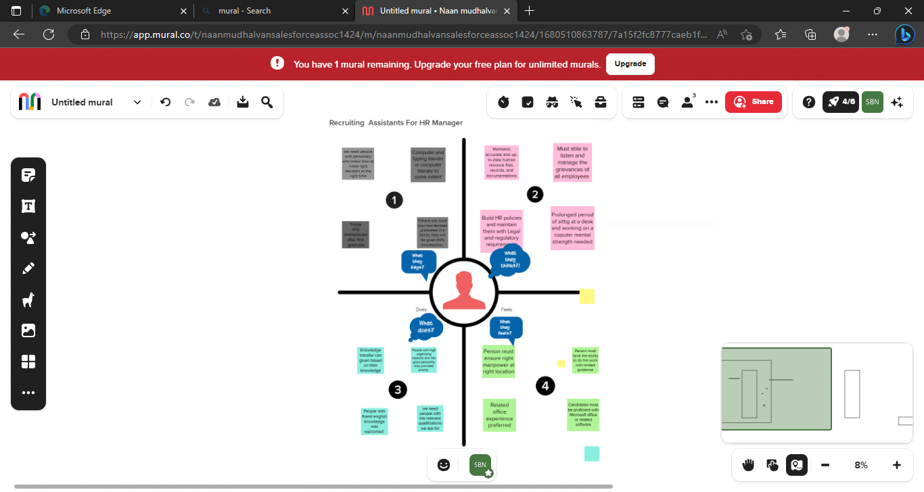ap**

**2.2 IDEATION & BRAINSTORMING**

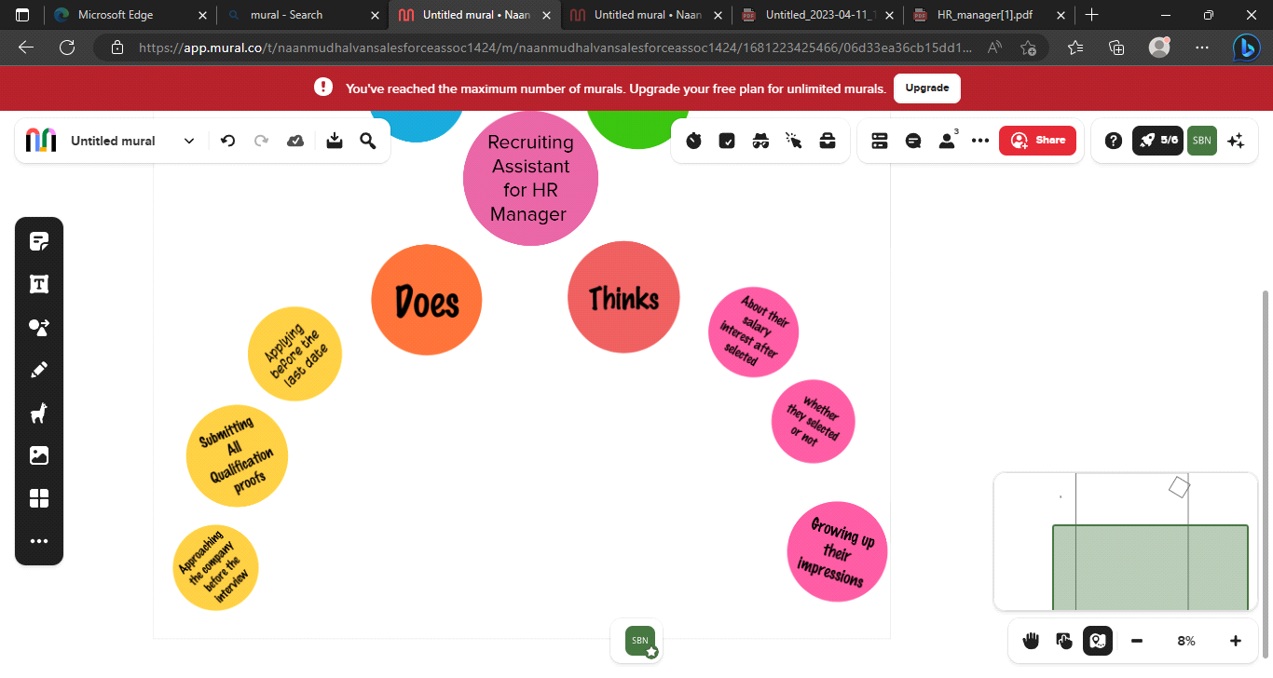

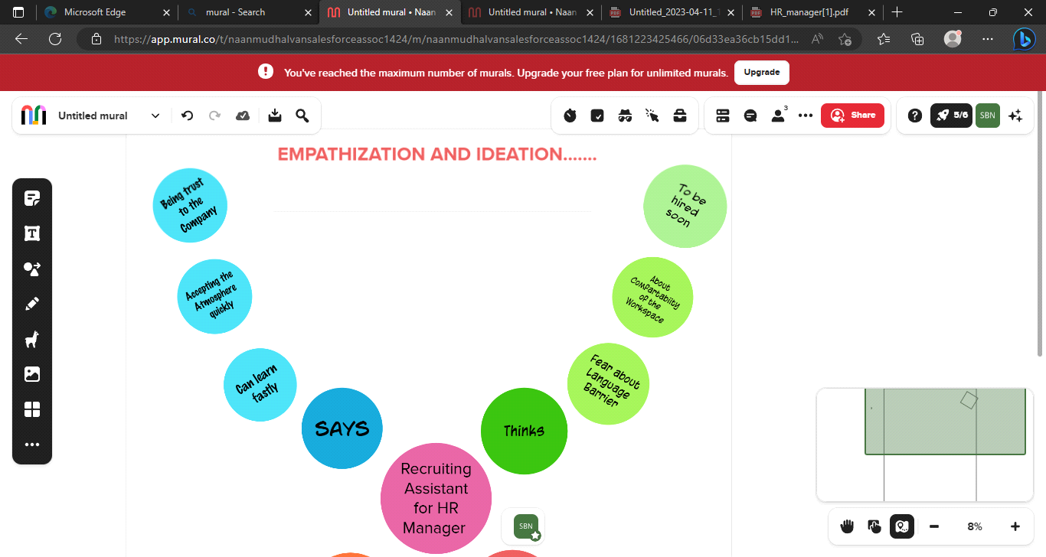

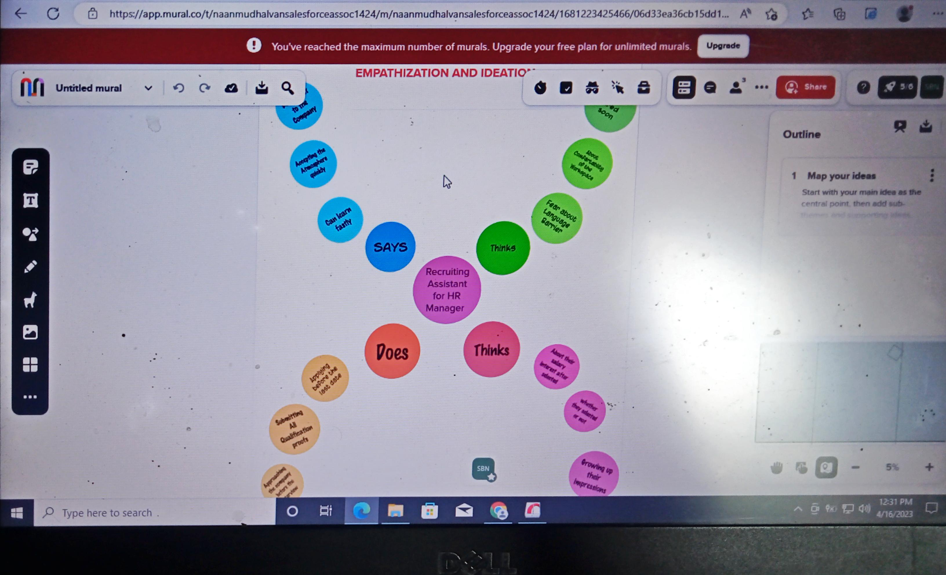

**RESULT**

3.1 Data Model:

|  |  |
| --- | --- |
| OBJECT NAME | FIELDS IN THE OBJECT |
| Object 1 | FIELD LABLE DATA TYPE  Job posting Site Text |
| Object 2 | FIELD LABLE DATA TYPE  Review Auto Number |
| Object 3 | FIELD LABLE DATA TYPE  Status Text |
| Object 4 | FIELD LABLE DATA TYPE  Technical Site Text |
| Object 5 | FIELD LABEL DATA TYPE  Description Text |
| Object 6 | FIELD LABEL DATA TYPE  Job posting Auto Number |

**3.2** Activity & Screenshots:

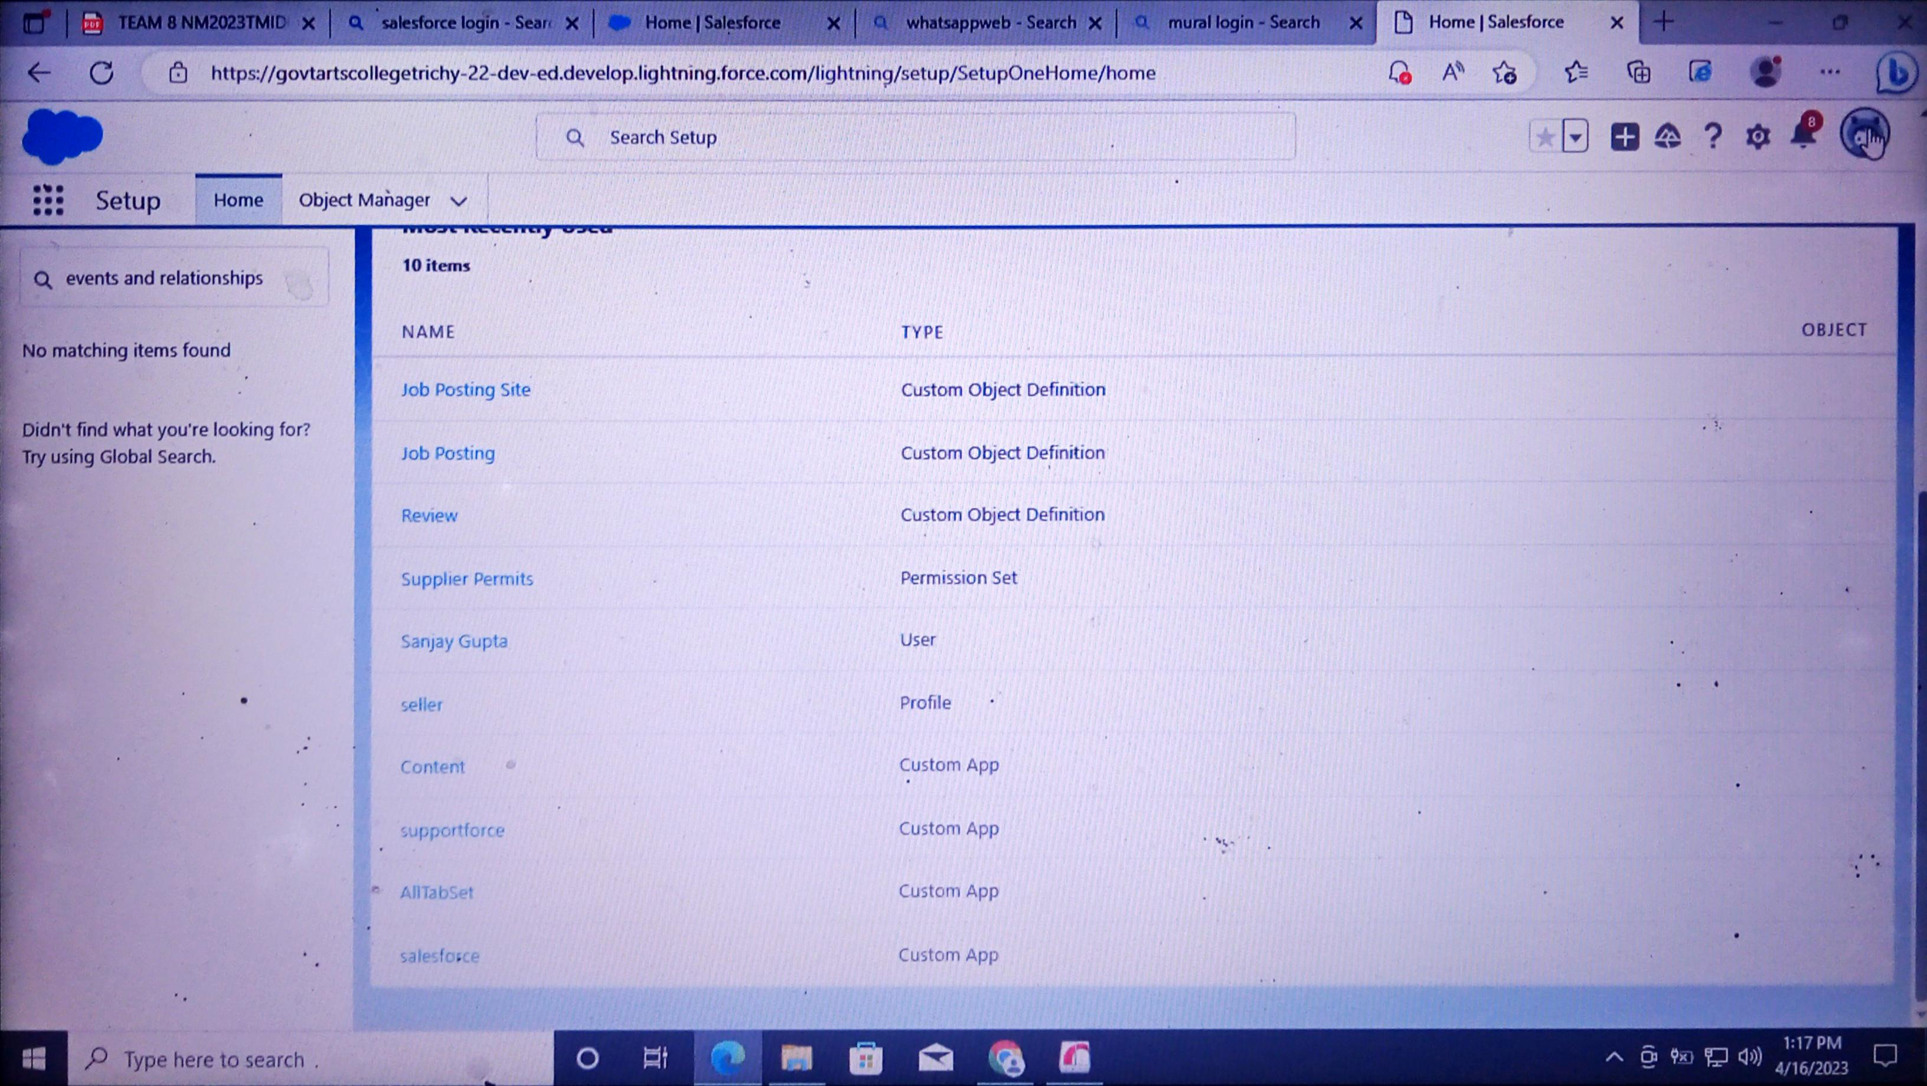

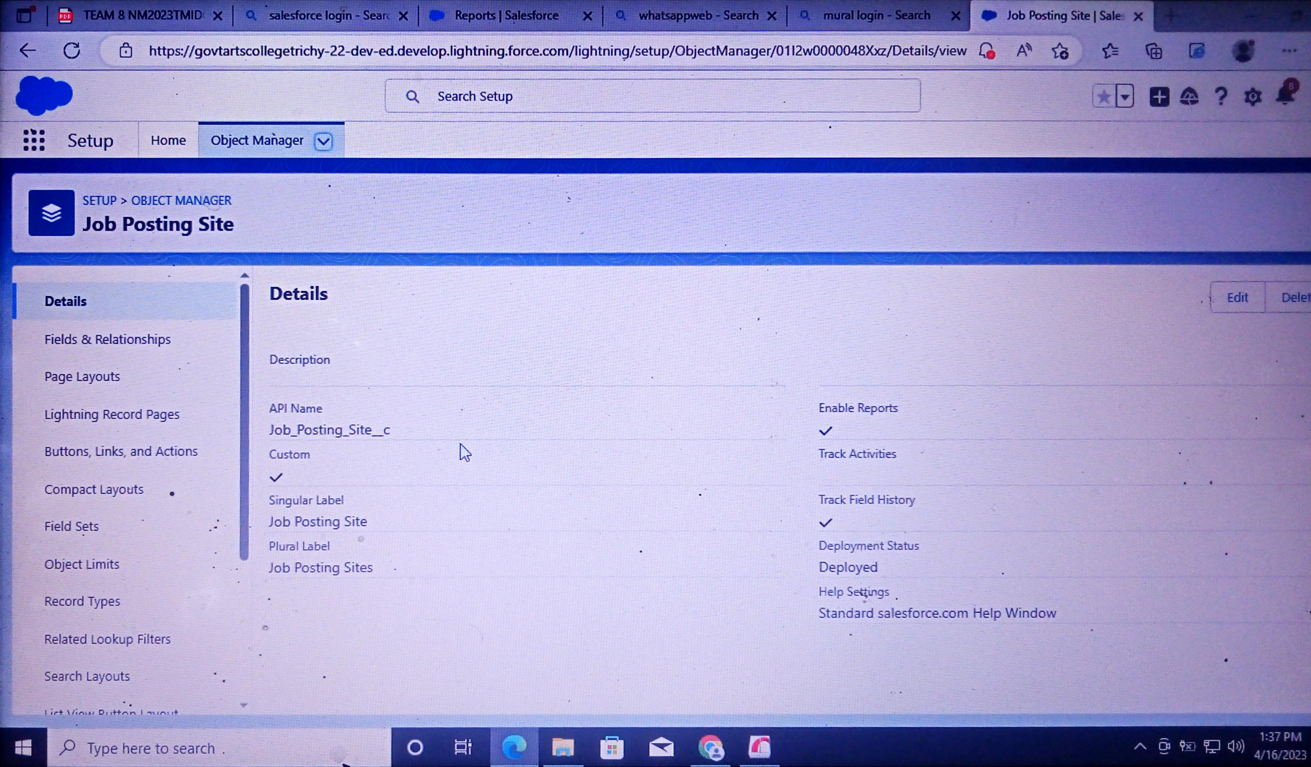

**Trialhead profile Public URL:**

**TEAM LEAD – https://trailblazer.me/id/sindhu09**

**TEAM MEMBER 1 – https://trailblazer.me/id/vkani9**

**TEAM MEMBER 2 –https://trailblazer.me/id/mkannaiyan1**

**TEAM MEMBER 3 -https://trailblazer.me/id/nbalamurugan4**

**5.1 ADVANTAGES**

* **Assures cultural fit**
* **Shorten on boarding times**
* **Subscribe to resume databases**
* **Provide job security to your employees**
* **Improves employee satisfaction**
* **Saves time and money**
* **Gain skilled employees**

**5.2 DISADVANTAGES**

* **LIMIT your pool of applicants**
* **Result in inflexible culture**
* **May leads to workplace hostility**
* **Recruitment agencies have limited choices**
* **Increases training costs of the new applicants**
* **Leave a gap in your existing workforce**
* **Creating jealousy**
* **Keyword misvaluable talent**
* **Encouraging unfair promotions**
* **Making a hole in the team**

**6 Application :**

* **Timesheet and time-off management**
* **Training and attendance management**
* **Performance review**
* **Employees self service**
* **Employees information system**
* **New staff hiring**
* **Applicants tracking**

**7 CONCLUSION :**

**Human resources assistant recruiter job responsibilities include filling open positions within timelines with talented and qualified candidates. They do sourcing of applicants, screening, organizing the interview process, and assisting the hiring manager in the interview and offer process.**

**Hereby I have submitted all my projects properly..**

**8 FUTURE SCOPE:**

* **Global recruiting**
* **Career boards and referrals**
* **Emphasis on diversity**
* **Modernized processes**
* **Machine learning to fight bias**